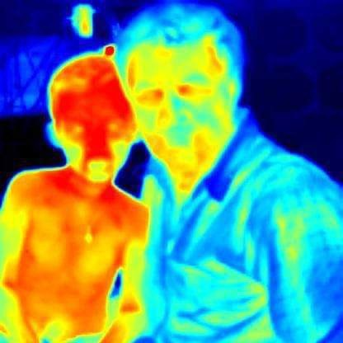  Dear Parent, Our Choose an item. Click or tap here to enter text. attends Click or tap here to enter text., Grade Click or tap here to enter text.. Click or tap here to enter text. appears slightly different to other children however, this is in appearance only. Click or tap here to enter text. has a genetic condition Ectodermal Dysplasia (ED), which affects (but not limited to): hair; teeth; sweat glands; tear ducts; skin; eyes; and ears. To date the issues facing Click or tap here to enter text. day to day activities include:  - Overheating:  Click or tap here to enter text. is a healthy normal little Choose an item.who loves to join in with outdoor activities however, Choose an item.has no sweat glands and therefore overheats very quickly.  - Teeth  Click or tap here to enter text. has only Click or tap here to enter text. teeth and wears a denture/plate. Choose an item. will require ongoing dental visits/treatments for the rest of Choose an item. life.  - Eyes  Click or tap here to enter text. has dry eye and requires eye drops on a daily basis. Choose an item. is also encouraged to wear sunglasses during outdoor activities.  - Hair  Click or tap here to enter text. has fine blonde hair which is quite sparse over his/her head. Choose an item. also does not have hair in his/her nose (cilia – which help trap foreign objects and clean out the nose). Choose an item. has to use fess (a saline solution in a pump spray) daily to help clean out Choose an item. nose.  - Skin  Click or tap here to enter text. has dry skin however, moisturisers are applied daily to help prevent this becoming a serious problem.  Thank you for taking the time to read this information. We hope you have a better understanding of Click or tap here to enter text. condition and possibly answer any questions your own children might have regarding Click or tap here to enter text..  Please feel free to contact us anytime if you have any concerns or questions.  Thank you, Click or tap here to enter text.  Phone: Click or tap here to enter text.  Email: Click or tap here to enter text.  For further information on Ectodermal Dysplasia please visit www.ozed.org.au.  ozED   info@ozed.org.au |  | Dear Parent, Our Choose an item. Click or tap here to enter text. attends Click or tap here to enter text., Grade Click or tap here to enter text.. Click or tap here to enter text. appears slightly different to other children however, this is in appearance only. Click or tap here to enter text. has a genetic condition Ectodermal Dysplasia (ED), which affects (but not limited to): hair; teeth; sweat glands; tear ducts; skin; eyes; and ears. To date the issues facing Click or tap here to enter text. day to day activities include:  - Overheating:  Click or tap here to enter text. is a healthy normal little Choose an item.who loves to join in with outdoor activities however, Choose an item.has no sweat glands and therefore overheats very quickly.  - Teeth  Click or tap here to enter text. has only Click or tap here to enter text. teeth and wears a denture/plate. Choose an item. will require ongoing dental visits/treatments for the rest of Choose an item. life.  - Eyes  Click or tap here to enter text. has dry eye and requires eye drops on a daily basis. Choose an item. is also encouraged to wear sunglasses during outdoor activities.  - Hair  Click or tap here to enter text. has fine blonde hair which is quite sparse over his/her head. Choose an item. also does not have hair in his/her nose (cilia – which help trap foreign objects and clean out the nose). Choose an item. has to use fess (a saline solution in a pump spray) daily to help clean out Choose an item. nose.  - Skin  Click or tap here to enter text. has dry skin however, moisturisers are applied daily to help prevent this becoming a serious problem.  Thank you for taking the time to read this information. We hope you have a better understanding of Click or tap here to enter text. condition and possibly answer any questions your own children might have regarding Click or tap here to enter text..  Please feel free to contact us anytime if you have any concerns or questions.  Thank you, Click or tap here to enter text.  Phone: Click or tap here to enter text.  Email: Click or tap here to enter text.  For further information on Ectodermal Dysplasia please visit www.ozed.org.au.  ozED 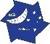  info@ozed.org.au

